Kandy Innovation Centre
National Institute of Business Management
MACHINE LEARNING AND RELATED APPLICATIONS

Review of Research Study

Performance Evaluation of Machine Learning and Deep Learning Models for Credit Risk Prediction

(Phase 1)
S M K I Wijethunga
Student Registration Number: KIC-BSCCSAI-251P-034

Kandy Innovation Centre,
National Institute of Business Management,
1095, Kandy - Colombo Rd, Getambe.
Date of Submission: 15/09/2026

1. Problem Formulation
The chosen study takes on the credit risk evaluation through the use of supervised classification which is dealt with binary classification indicating good credit risk and bad credit risk (in other words, in terms of default and no default). The authors tested their comparative models on two standard datasets witnessing the results under various scales and levels of richness of the data.

1.1 Dataset Details
Dataset | Scale | Source & Year | Classification Task
German Credit | 1,000 records, 20 features, ~30% minority class (bad credit) | UCI Machine Learning Repository (Hofmann, 1994); segmentation basis per Boughaci et al., 2021 | Binary
Taiwan Credit | 30,000 records, 23 features, ~22.1% minority class (default) | UCI Machine Learning Repository (Yeh & Lien, 2009) | Binary

1.2 Nature of Learning Task
- Learning type: supervised classification, only binary (unlike those researching intrusion detection methods, where attack types are simultaneously modeled).
- Class imbalance: moderate in this work and explicitly mentioned as the topic of investigation (with severity degrees as 30% minority in the case of German samples and 22.1% in the case of Taiwan samples).
- Dimensionality: 20 variables for the German data and 23 variables for the Taiwan data. A distinctive characteristic of this research is the decision to keep all variables intact in the ten developed models, without the necessity to use feature reduction methods (such as PCA, etc.).
- Framing against prior work: the study sets itself against previous works that investigate resampling methods and ML/DL models separately.

1.3 Feature Composition Breakdown
 | German Credit | Taiwan Credit
Categorical features | 13 of 20 (e.g., CheckingAccount, CreditHistory, Purpose, Housing) | 3 of 23 (SEX, EDUCATION, MARRIAGE)
Numeric features | 7 of 20 (Duration, CreditAmount and Age are continuous; InstallmentRate, ResidenceSince, ExistingCredits and NumDependents are small-integer ordinal/count variables) | 20 of 23 (LIMIT_BAL, AGE, 6× BILL_AMT and 6× PAY_AMT are numeric values; the 6× PAY_ columns are ordinal repayment-status codes from −2 to 8)
Repeated-measure structure | None (all features are single snapshot) | Present PAY_0 and PAY_2–PAY_6, BILL_AMT1–6, PAY_AMT1–6 form 6 month sequences
This distinction is relevant to section 2: the German data rely mostly on categorical features, while the Taiwan data are mainly numeric and include genuine repeated measures. The difference here forms the basis for the assessment of the fit of designs in section 2.2.

1.4 Statistical Profile and Exploratory Data Analysis
The datasets were both profiled statistically (my own analysis of the UCI data), as the form of the features determines which pre-treatments and methods are suitable. Variance is considered the square of the standard deviation (σ²).
Table 1.4a – German Credit, numeric features (n = 1,000)
Feature | Mean | Median | SD | Skewness | Excess kurtosis
Duration (months) | 20.90 | 18 | 12.06 | 1.09 | 0.91
CreditAmount (DM) | 3,271 | 2,320 | 2,823 | 1.95 | 4.27
Age | 35.55 | 33 | 11.38 | 1.02 | 0.59
InstallmentRate | 2.97 | 3 | 1.12 | −0.53 | −1.21
ResidenceSince | 2.85 | 3 | 1.10 | −0.27 | −1.38
ExistingCredits | 1.41 | 1 | 0.58 | 1.27 | 1.59
NumDependents | 1.16 | 1 | 0.36 | 1.91 | 1.64
Table 1.4b – Taiwan Credit, selected numeric features (n = 30,000; BILL_AMT2–5 and PAY_AMT3–6 behave like their neighbours)
Feature | Mean | Median | SD | Skewness | Excess kurtosis
LIMIT_BAL | 167,484 | 140,000 | 129,748 | 0.99 | 0.54
AGE | 35.49 | 34 | 9.22 | 0.73 | 0.04
PAY_0 | −0.02 | 0 | 1.12 | 0.73 | 2.72
PAY_6 | −0.29 | 0 | 1.15 | 0.95 | 3.43
BILL_AMT1 | 51,223 | 22,382 | 73,636 | 2.66 | 9.80
BILL_AMT6 | 38,872 | 17,071 | 59,554 | 2.85 | 12.27
PAY_AMT1 | 5,664 | 2,100 | 16,563 | 14.67 | 415.2
PAY_AMT2 | 5,921 | 2,009 | 23,041 | 30.45 | 1,641.4
Distribution and normality: No numerical attribute shows a normal distribution. The Shapiro-Wilk test confirms that normality is rejected for all numerical features in both datasets (p<0.001; in the case of Taiwan, this test was performed for a random sample made out of 5,000 rows since the procedure might become overly sensitive with larger sample sizes). Moreover, monetary variables have a strong right skewness and are characterized by heavy tails; for instance, the average German credit amount equals 3,271 with the median being 2,320, while the Taiwanese PAY_AMT2 has the skewness coefficient equal to 30.5 and the excess kurtosis coefficient equal to 1,641. However, the log-transformation helps to decrease the skewness of the German Credit Amount, which goes down from 1.95 to 0.13. Therefore, transformation techniques are advisable for linear, distance-based, and neural models, while tree-based approaches do not change with the help of monotonic transformations. It is worth mentioning that this paper does not use any transformation technique.
Scale (variance): Variance values for the features go from 0.13 (German NumDependents) to about 7.97 × 10⁶ (German CreditAmount) and 1.68 × 10¹⁰ (Taiwan LIMIT_BAL). In the absence of scaling, the money-related features would overpower both gradient-based models and distance-based resampling methods, such as ENN and SMOTE.
Relationships: In the German data, the values for Duration and CreditAmount correlate positively (about 0.62 according to both spearman and pearson). In Taiwan, the six BILL_AMT features are inter-correlated (0.73–0.91 for spearman and 0.92–0.95 for pearson from month to month), reflecting the same account balance for the same account every month. This situation creates high variance of regression coefficients in logistic regression but does not influence the tree-based ensemble models.
Features vs target: In the German data, it is observed that bad-credit rate decreases with the increase in the status of checking account: 49.3% (with account balance less than zero), 39% (with account balance from 0 to 200 DM), 22.2% (with an account balance of 200 DM and more), and 11.7% (without account). On the contrary, in Taiwan, the most significant predictor is the most recent payment status PAY_0 (Spearman correlation with the default = 0.29). The default rate is equal to 13–17% in cases with payment statuses between −2 to 0; however, in cases with one month of delay payments, the default rate leaps to 33.9%, while in the case of a two-month delay it reaches 69.1%. In addition, credit limit is negatively related to default: the default rate falls from 31.8% in the lowest limit quartile to 14.0% in the highest.
Findings and their consequences:
- Skewed distributions require log transformation or tree-based modeling.
- Significant disparities in scales necessitate scaling for Logistic Regression, SVM, artificial neural networks, and distance-based resampling.
- The correlated BILL_AMT block motivates regularization or feature elimination.
- The moderate class imbalance motivates resampling or class weights adjustment.
- Four German numeric features that actually are ordinal should not be treated as continuous.

1.5 Data Quality Issues and Dataset Limitations
- Missing values: no missing in either dataset as also stated in the UCI description. Hence, imputation is not needed in the paper, but it does not mention it.
- Duplicates: there are no duplicates in the German data. In Taiwan, there are 35 duplicates after removing the ID column, which is only 0.12% of the sample and the paper does not mention it.
- Undocumented codes (Taiwan): while the data dictionary claims for EDUCATION to have values of 1–4 and MARRIAGE to have 1–3 values, there are EDUCATION codes of 0 (that is 14 clients), 5 (280 clients) and 6 (51 clients) in the data, and the MARRIAGE code of 0 (54 clients). In for PAY_0 repayment variable, the data has the value of −2 (2,759 clients), while it also has the value of 0 (14,737 clients; 49% of the sample), although the data dictionary gives only −1 and values from 1 to 9. The undocumented EDUCATION codes display different trends from the main categories of default: 0% for code 0, 6.4% for code 5 and 15.7% for code 6, as opposed to 19–25% for the codes from 1 to 3. By merging them as other without any explanation this situation is concealed. The paper does not elaborate on how these codes were treated.
- Naming inconsistency: the first column for repayments is PAY_0, while the others are PAY_2 to PAY_6, which may yield confusion due to off-by-one mistakes in case this period of six months is seen as a time series chain in LSTM/GRU processes.
- Outliers: according to the IQR rule, approximately 8-9% of BILL_AMT values and 9-10% of PAY_AMT values from Taiwan have been flagged, whereas only 7% in Duration variable and 7.2% in CreditAmount for German. Such amounts are valid amounts and not mistakes and should stay or be capped but not disregarded. The IQR rule does not work for discrete features, because it flagged 15.5% in German NumDependents though the variable has only the values 1 and 2.
- Questionable values (Taiwan): the number of clients having negative bills is constantly between 590-688, which means that maybe the clients have credit balances owing to overpayments, but this is not supported by any documentation, while 7% of clients did have their bills in September exceeding the total credit approved limit; additionally, 17.5% of clients have not made any payment in September.
- Near-constant feature (German): 963 out of 1000 clients are foreign workers and therefore this feature has almost no information value.
- Counter-intuitive correlation (German): customers having “no credits taken / all credits paid back” suffer from a 62.5% bad ratio (n = 40), while those holding “critical account” have only 17.1% (n = 293), indicating selection bias or label noise.
- Sample-selection bias (both): there are only outcomes available that were given credits, so models cannot learn about the refused customers.
- Small sample (German): 300 bad-credit customers leave only about 30 minority customers per validation fold during 10-fold CV, meaning that fold-to-fold variance is very high and differences in a few percent cannot be taken as a convincing evidence.
- Age and representativeness: German Credit was released in 1994 and Taiwan’s data include the period from April to September 2005 for one bank. In neither case does the data allow to say that it is representative for current products and markets.
- Cost asymmetry: the German dataset provides a cost matrix in which misclassifying a bad customer as good costs 5 whereas the reverse costs only 1. The metrics Accuracy and F1 do not take this into account.
- Leakage check: all features from Taiwan represent the months before the outcome, thus no target leakage was found.

1.6 Scope, Assumptions and Success Criteria
Task and decision: The lender makes a decision whether to approve the loan or not; the classifier assists the lender in predicting the probability of default.
Formulation: The variable of interest is y ∈ {0, 1}, and y = 1 signifies bad credit/default (the positive class). The inputs in this case are x ∈ ℝ²⁰ in Germany (13 categorical inputs and 7 numerical inputs) and x ∈ ℝ²³ in Taiwan (3 categorical inputs and 20 numerical inputs). It is a supervised binary classification problem to learn a function f: X → {0, 1} which minimizes the expected misclassification loss.
Assumptions: The assumptions made are that the samples are independent of each other and that they are distributed similarly, also that populations during training and deployment match, meaning that there is no concept drift, labels should be reliable, and all features are available at the time of making the decision.
Scope and limitations: Scope and limitations of the analysis are that two publicly available tabular datasets are used, one cross-validation protocol is applied, and no cost-based or fairness analysis has been performed. Conclusions of this analysis would not be applied beyond the sampled banks or countries.
Success criteria: A majority-class predictor achieves an accuracy of 70.0% on the German data and 77.9% on the Taiwan data, yet has 0% recall, so accuracy alone cannot indicate model quality. A good model must beat this benchmark on minority-class recall, F1 and PR-AUC; the chance level of PR-AUC equals the prevalence (0.30 for German and 0.221 for Taiwan).

1.7 Ethical Considerations
Both datasets contain attributes that are legally or ethically sensitive in lending: age, personal status and sex, and foreign-worker status (German); SEX, AGE, MARRIAGE and EDUCATION (Taiwan). The German personal-status attribute merges sex and marital status and has no category for single women. The data show clear group differences: the bad-credit rate is 40.9% for applicants under 25 (n = 149) against 28.1% for others, and the Taiwan default rate is 24.2% for men against 20.8% for women. Models can therefore learn these attributes or their proxies and produce discriminatory decisions. A false positive (wrongly denying credit) harms the customer, while a false negative harms the lender. The paper uses SHAP for interpretability but includes no fairness audit, and interpretability alone does not establish fairness. The data are also personal financial records, so privacy and misuse must be considered.

2. Methodological Justification
Ten supervised classifiers are evaluated, split into two families:
- Traditional ML: (Logistic Regression, SVM, Decision Tree, Random Forest, XGBoost, AdaBoost)
- Deep learning: (MLP, CNN, LSTM, GRU).
By isolating the effect of the ensemble technique while keeping the base learner unchanged, we justify the choice of the standard ML approach (single tree → bagging → boosting), which is a valid methodological choice.

2.1 The Three Resampling Techniques Evaluated
- SMOTE (Synthetic Minority Over-sampling Technique): creates synthetic samples of the minority class by interpolation between a real minority instance and one of its nearest neighbors, thus producing convex combinations and ensuring that it always stays within the bounds of observed minority distribution.
- x_new = x + δ · (x_neighbour − x), δ ∈ [0, 1]
- ENN (Edited Nearest Neighbours): This is an example of an undersampling method, whereby instances of the majority class are removed when incorrectly classified by the majority of their nearest neighbours to eliminate noise from majority samples and borderline classes.
- SMOTE-ENN: First, the SMOTE method is employed for raising the number of instances from the minority class, and then the method of ENN is used to remove noise from the dataset.

2.2 Strength and Limits of the Justification
The motivation presented in this paper the fact that the existing literature has a systematic disconnection between resampling method and model architecture in datasets with a varying scale is adequately backed up and convincingly discussed, with the statement of secure usage of the resampling technique (Section 3) serving as evidence of this claim.
On the contrary, the rationale behind using CNN and LSTM/GRU for this task is less convincing in comparison with the classical ML methods. While both of the architectures are based on the idea of local correlation in the case of CNN and time dependency, the authors themselves admit that the German Credit dataset does not possess any of the properties confided in CNN (further verified in Section 1.3 as well). The authors present the application used in the paper as being utilized in the context of benchmarking and not fitting the corresponding task quite accurately, which diminishes the strength of the argument for deep learning being superior in this respect. The contrast between the German best score (MLP + SMOTE-ENN, F1 = 0.937) and the best result for Taiwan (Random Forest + SMOTE-ENN, F1 = 0.610), keeping the experimental procedure the same, adds to this idea. This difference can hardly be explained by model quality alone, since the experimental procedure was identical; it more plausibly reflects dataset size and structure (a small categorical German sample against a larger Taiwan sample with a weaker signal).
The authors' stated aim is to isolate the effect of the ensemble technique (single tree → bagging → boosting), with Logistic Regression and SVM as interpretable and margin-based baselines and four neural architectures to test whether deep learning adds value. Alternatives that were not evaluated include k-nearest neighbours, Naive Bayes, gradient boosting with native categorical handling (LightGBM, CatBoost) and tabular-specific deep models. Benchmark studies commonly report that tree-based models remain competitive with or superior to deep networks on typical tabular data, which makes the heavy investment in CNN and LSTM/GRU harder to justify.

2.3 Worked Calculations Verifying the Model Equations
To verify the mathematical functioning outlined in the second section of the paper, the following empirical calculations were made, using suitable numbers commensurate with the used datasets.
(a) Logistic Regression: sigmoid activation. Consider the case of an input with weighted signals z = w·x + b = 0.5:
σ(0.5) = 1 / (1 + e^(−0.5)) = 1 / (1 + 0.6065) = 0.6225
This verifies that the sigmoid function transforms a linear value into a useful probability taking values in (0, 1), which serves as the base of the claims made by the paper regarding log-odds interpretation of the outputs of the Logistic Regression algorithm.
(b) SVM: margin as a function of ‖w‖. For w = (3, 4), the magnitude of the learned vector, ‖w‖, is computed as follows:
‖w‖ = √(3² + 4²) = 5
Thus, the margin yields:
margin = 2 / ‖w‖ = 2 / 5 = 0.4
In the case of a smaller vector w = (1, 1), it can be calculated that:
‖w‖ = √2 = 1.414, margin = 1.414
Thus, we can conclude that minimizing ‖w‖ throughout the phase of SVM training results in maximizing margin and is consistent with the rest of the discussions in the paper concerning the use of SVM as a baseline method.
(c) Random Forest: decision-making follows majority voting principles. When predicting on 7 trees with the output given by [1, 0, 1, 1, 0, 1, 1]:
ŷ = mode({1,0,1,1,0,1,1}) = 1 (5 votes for '1' against 2 votes for '0')
This is reflective of how Random Forest works as an aggregation algorithm that is meant to lower the variability that a single decision tree exhibits, thus confirming what the authors of the paper have referred to previously in the bias variance argument aspect.
(d) SMOTE: Given a minority instance x = (Duration = 24, CreditAmount = 3000) and a neighboring instance x_neighbour = (36, 4000) where δ = 0.4:
x_new = (24 + 0.4×(36−24), 3000 + 0.4×(4000−3000)) = (24 + 4.8, 3000 + 400) = (28.8, 3400)
As we can see, both of the coordinates in x_new remain within the coordinate values of x and x_neighbour and this is a numerical illustration that SMOTE works by creating points that are convex combinations of actual minority points as described in Section 2.1.

2.4 Workflow of the Authors’ Method and Justification of Each Step
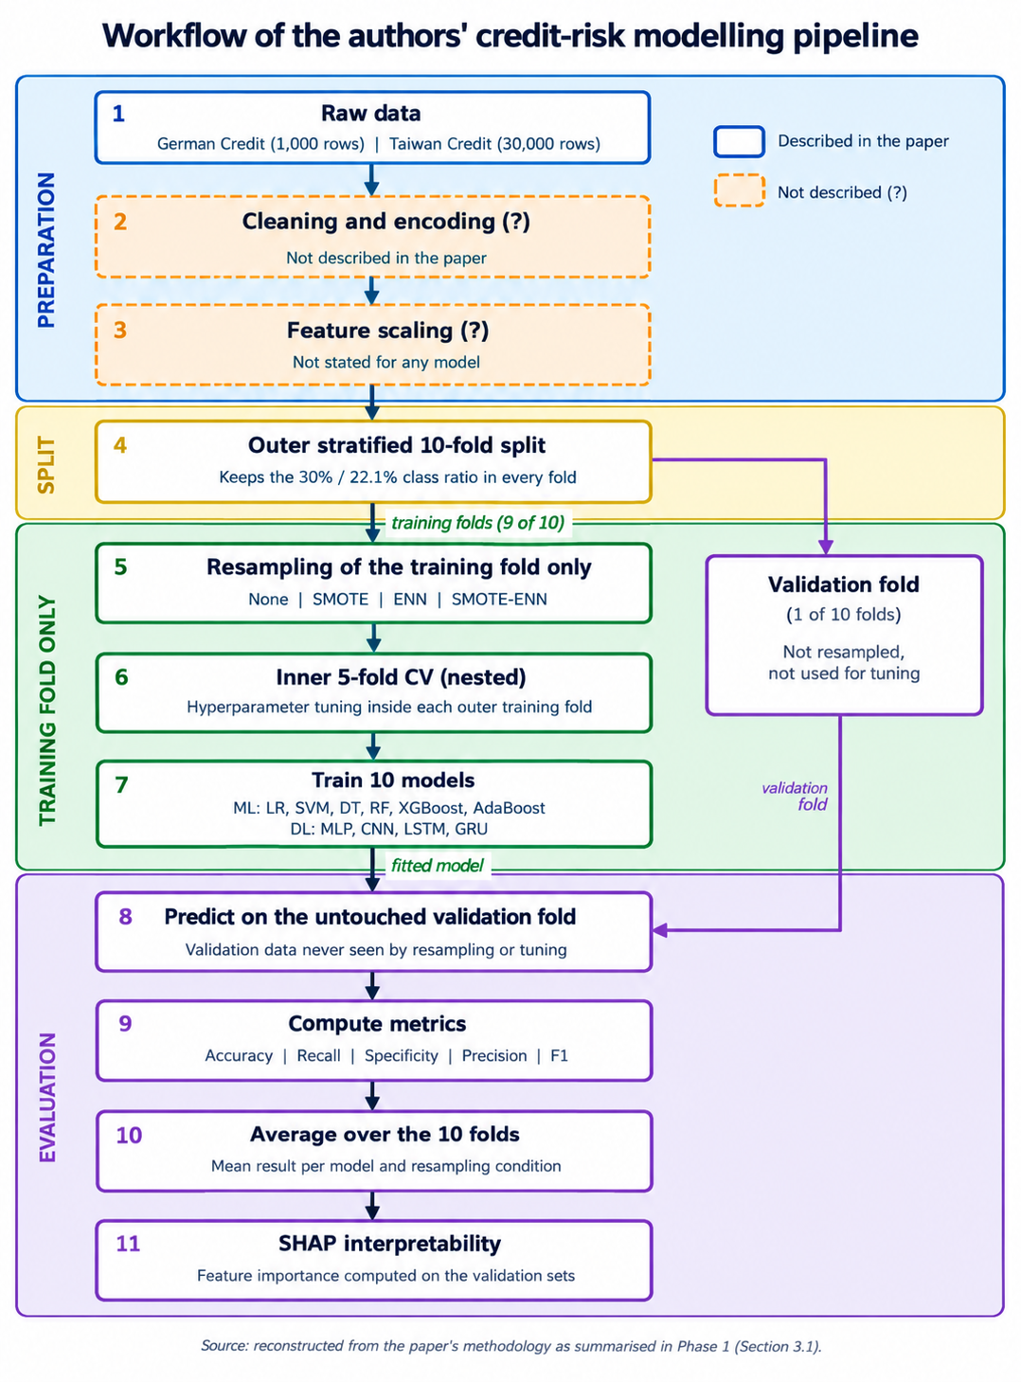
Figure 2.4: The authors’ credit-risk modelling workflow. Orange dashed rectangles indicate which operations are omitted in this paper. Resampling and hyperparameter adjustment apply only to the training folds whereas the test fold is employed only for prediction and assessment. Source: reconstructed from the paper methodology (refer to Section 3.1).
Preparation (steps 1-3). The datasets German Credit (1,000 records) and Taiwan Credit (30,000 records) are obtained. The paper does not specify whether categorical features were encoded or if and how features were normalized, which accounts for the question marks against these two processes. Both encoding and normalization are crucial: the encoding of categorical data defines if SMOTE can provide meaningful interpolation while normalization is relevant for distance-based resampling techniques and some neural networks based on the gradients.
Splitting (step 4). The data are divided by means of stratified 10-fold cross-validation, keeping original class ratios (approx. 30% bad credits in Germany and 22.1% defaults in Taiwan). Thus, in every iteration, nine folds are used for training and one fold is used for validation.
Training (steps 5–7). In the training process, only training folds are subjected to resampling using one of the following techniques: no resampling, SMOTE, ENN or SMOTE-ENN. After that, hyperparameters are fine-tuned with an inner 5-fold cross-validation nested inside the outer training set and ten classifiers (six traditional ML models and four deep learning models) are trained using the chosen parameters. Since resampling and fine-tuning are not performed on the held-out fold, synthetic samples cannot contaminate the evaluation which is a significant methodological advantage.
Evaluation (steps 8 - 11). The first step in evaluation is where each model that has been trained will be tested against the untouched validation fold. The measures that are calculated in this phase include accuracy, recall, specificity, precision and F1 score, which must be reported as an average across the ten folds for each model and for every resampling condition, and the last element of this stage is the use of SHAP to determine the contribution of different features in making predictions.
Why each step, and the alternatives:
- Stratified 10-fold CV: preserves the 30% / 22.1% class ratio in every fold. Alternatives: a single hold-out split (high variance on 1,000 rows) or repeated CV (more stable).
- Resampling inside folds: keeps synthetic points out of validation data. Alternatives: class weights, cost-sensitive learning, SMOTE-NC for mixed data.
- Scaling: needed by Logistic Regression, SVM, neural networks and the distance-based SMOTE and ENN; not needed by tree-based models. Standardisation is preferable to min-max scaling for skewed financial amounts, because min-max is dominated by outliers.
- Encoding: one-hot avoids a false order but raises dimensionality; ordinal encoding implies an order; target encoding risks leakage unless fitted within each fold.
- Nested CV for tuning: avoids the optimistic bias of tuning and evaluating on the same folds.

2.5 Mathematical Aspects of the Algorithms
Logistic Regression: p(y = 1 | x) = σ(wᵀx + b). The loss function is binary cross-entropy, i.e., L = −(1/n) Σ [yᵢ log pᵢ + (1 − yᵢ) log(1 − pᵢ)] (+ λ‖w‖² term for L2). Since L is convex, the gradient descent is guaranteed to find the best solution; scaling ensures that the regularization is comparable across the variables.
SVM: ½‖w‖² + C Σ ξᵢ needs to be minimized subject to the constraint that yᵢ(wᵀxᵢ + b) ≥ 1 − ξᵢ; margin = 2/‖w‖. C affects the trade-off between the margin size and the misclassification rate. For the RBF kernel K(x, x′) = exp(−γ‖x − x′‖²), a high value of γ gives a flexible boundary prone to overfitting. SVMs are sensitive to scaling and kernel learning is expensive for 30,000 examples.
Decision tree and Random Forest: Node impurity is measured by the Gini index G = 1 − Σ pₖ² or by entropy H = −Σ pₖ log₂ pₖ; each split is chosen to maximise the impurity decrease. Key parameters are n_estimators, max_depth, min_samples_leaf and max_features. Worked example at the root node: German (p = 0.30) gives G = 1 − (0.7² + 0.3²) = 0.420 and H = 0.881 bits; Taiwan (p = 0.2212) gives G = 0.345 and H = 0.762 bits.
Boosting: AdaBoost alters the weights of the wrongly classified observations, and αₜ = ½ ln((1 − εₜ)/εₜ) represents the weight given to trees. XGBoost performs a minimization of Σ l(yᵢ, ŷᵢ) + Σ Ω(f_k) where Ω = γT + ½λ‖w‖² imposes penalties on the sizes of the trees and the weights of their leaves.
Bias–variance: A single deep tree has high variance. Averaging B trees whose predictions have pairwise correlation ρ gives Var = ρσ² + (1 − ρ)σ²/B; with ρ = 0.3 and B = 100 this equals 0.307σ², so adding more trees cannot reduce the variance below ρσ². Random feature subsets lower ρ.
Neural networks: A dense layer computes h = φ(Wx + b); the output uses a sigmoid with cross-entropy loss; backpropagation applies the chain rule, ∂L/∂W = ∂L/∂h · ∂h/∂W; and weights are updated by SGD (w ← w − η∇L) or by Adam. A 1-D CNN computes (x ∗ k)ᵢ = Σⱼ kⱼ xᵢ₊ⱼ and assumes neighbouring inputs are related, which is not true of the German features (an unordered mix of categorical and ordinal variables). LSTM/GRU gating (e.g., cₜ = fₜ ⊙ cₜ₋₁ + iₜ ⊙ gₜ) suits sequential data, which exist only in the six-month records of the Taiwan data.

2.6 Evaluation Method and Hyperparameter Tuning Strategy
The approach taken by the authors (10-fold CV and nested tuning with the fixed seed and in-fold cross-validation) is valid. Certain flaws can be found in the measurement process employed and the selection of results. Specifically:
- Accuracy is misleading, since the majority-class performs at 70.0% in the German dataset and at 77.9% in the Taiwanese one.
- No threshold-free or imbalance-robust metrics were used: ROC-AUC, PR-AUC and MCC are all absent.
- No cost-sensitive metric has been used in the German case, although the cost matrix is known to be 5:1.
- Only one 10-fold CV run was performed, with no variance or significance testing. With only about 30 minority cases per German fold, differences of a few percentage points lie within noise.
- Selection bias: if the headline result is the best of 10 models × 3 resampling conditions, it is optimistic, because the final selection reuses the same CV scores.
Recommended evaluation: repeated stratified nested CV, mean ± SD, PR-AUC, MCC, and recall with preset specificity, statistical analysis based on Wilcoxon test across folds, and cost-sensitive error applied for German.
Tuning strategy: random search is more efficient than grid search when only few hyperparameters are involved, while grid search grows exponentially with the number of hyperparameters. Regardless of the technique authors used, tuning should be done during inner loop of nested CV, and not on the validation folds.

2.7 How Random Forest Works for This Problem
Every tree is built on a bootstrap sample of the training fold. The theoretical proportion of distinct rows in each tree is given by 1 − (1 − 1/n)ⁿ ≈ 1 − e⁻¹ = 63.2%, which means that roughly 632 rows out of 1000 German data (or roughly 18,960 out of 30000 Taiwan data) will be in-bag. The rest of the 36.8% comprise the out-of-bag sample, which is useful for creating an internal error estimate. While splitting, only about √d attributes are used: about 4 out of the 20 (German) and 4 out of the 23 (Taiwan), which makes the trees less correlated with one another. A split is chosen by the largest impurity decrease, and the forest predicts by majority vote (Section 2.3c).
The Taiwan case: the root node has G = 0.345. The split based on whether PAY_0 ≥ 2 separates 3130 clients (with 69.6% default and G = 0.424) from 26870 clients (with 16.6% default and G=0.277). The impurity in weighted down child is equal to 0.292 and the reduction in impurity equals 0.052. This is why repayment status dominates the early splits.
After SMOTE-ENN the training classes become closer to balanced, so the root impurity rises toward its maximum of 0.5 and the trees no longer favour the majority class. This helps explain why Random Forest with SMOTE-ENN gives the authors' best Taiwan result: the data are mostly numeric, with strong threshold effects (PAY_0) and repeated monthly measures, which trees handle without scaling.

3. Data Pipeline Analysis

3.1 Preprocessing Pipeline as Implemented
Step | Operation | What the Authors Did
1 | Data acquisition | German (1,000 records) and Taiwan (30,000 records) datasets acquired; Data Availability Statement cites Kaggle mirrors rather than the original UCI hosts.
2 | Missing values | Not described. Neither dataset contains missing values, so no imputation was needed, but the paper does not say so.
3 | Outliers | Not described. No capping, winsorising or transformation is reported, although 8–10% of Taiwan monetary values are IQR outliers.
4 | Duplicates and inconsistent codes | Not described. 35 duplicate Taiwan rows and undocumented codes (EDUCATION 0/5/6, MARRIAGE 0, PAY −2 and 0) are not addressed.
5 | Cleaning & encoding | Not explicitly described - no stated encoding scheme for the largely categorical feature sets in either dataset.
6 | Feature scaling | Not stated for any model, including the gradient-based MLP/CNN/LSTM/GRU architectures, where scaling materially affects training stability.
7 | Resampling (SMOTE / ENN / SMOTE-ENN) | Applied strictly within each training fold only, never touching the corresponding validation fold.
8 | Train/validation split + CV | 10 fold stratified cross-validation with a fixed random seed; nested 5-fold inner CV used for hyperparameter tuning within each outer training fold.
9 | Model training & evaluation | All ten models trained under each resampling condition; evaluated via accuracy, recall, specificity, precision, and F1-score.
10 | Interpretability (SHAP) | Applied post training to compute feature importance on the validation sets, visualised via summary plots.
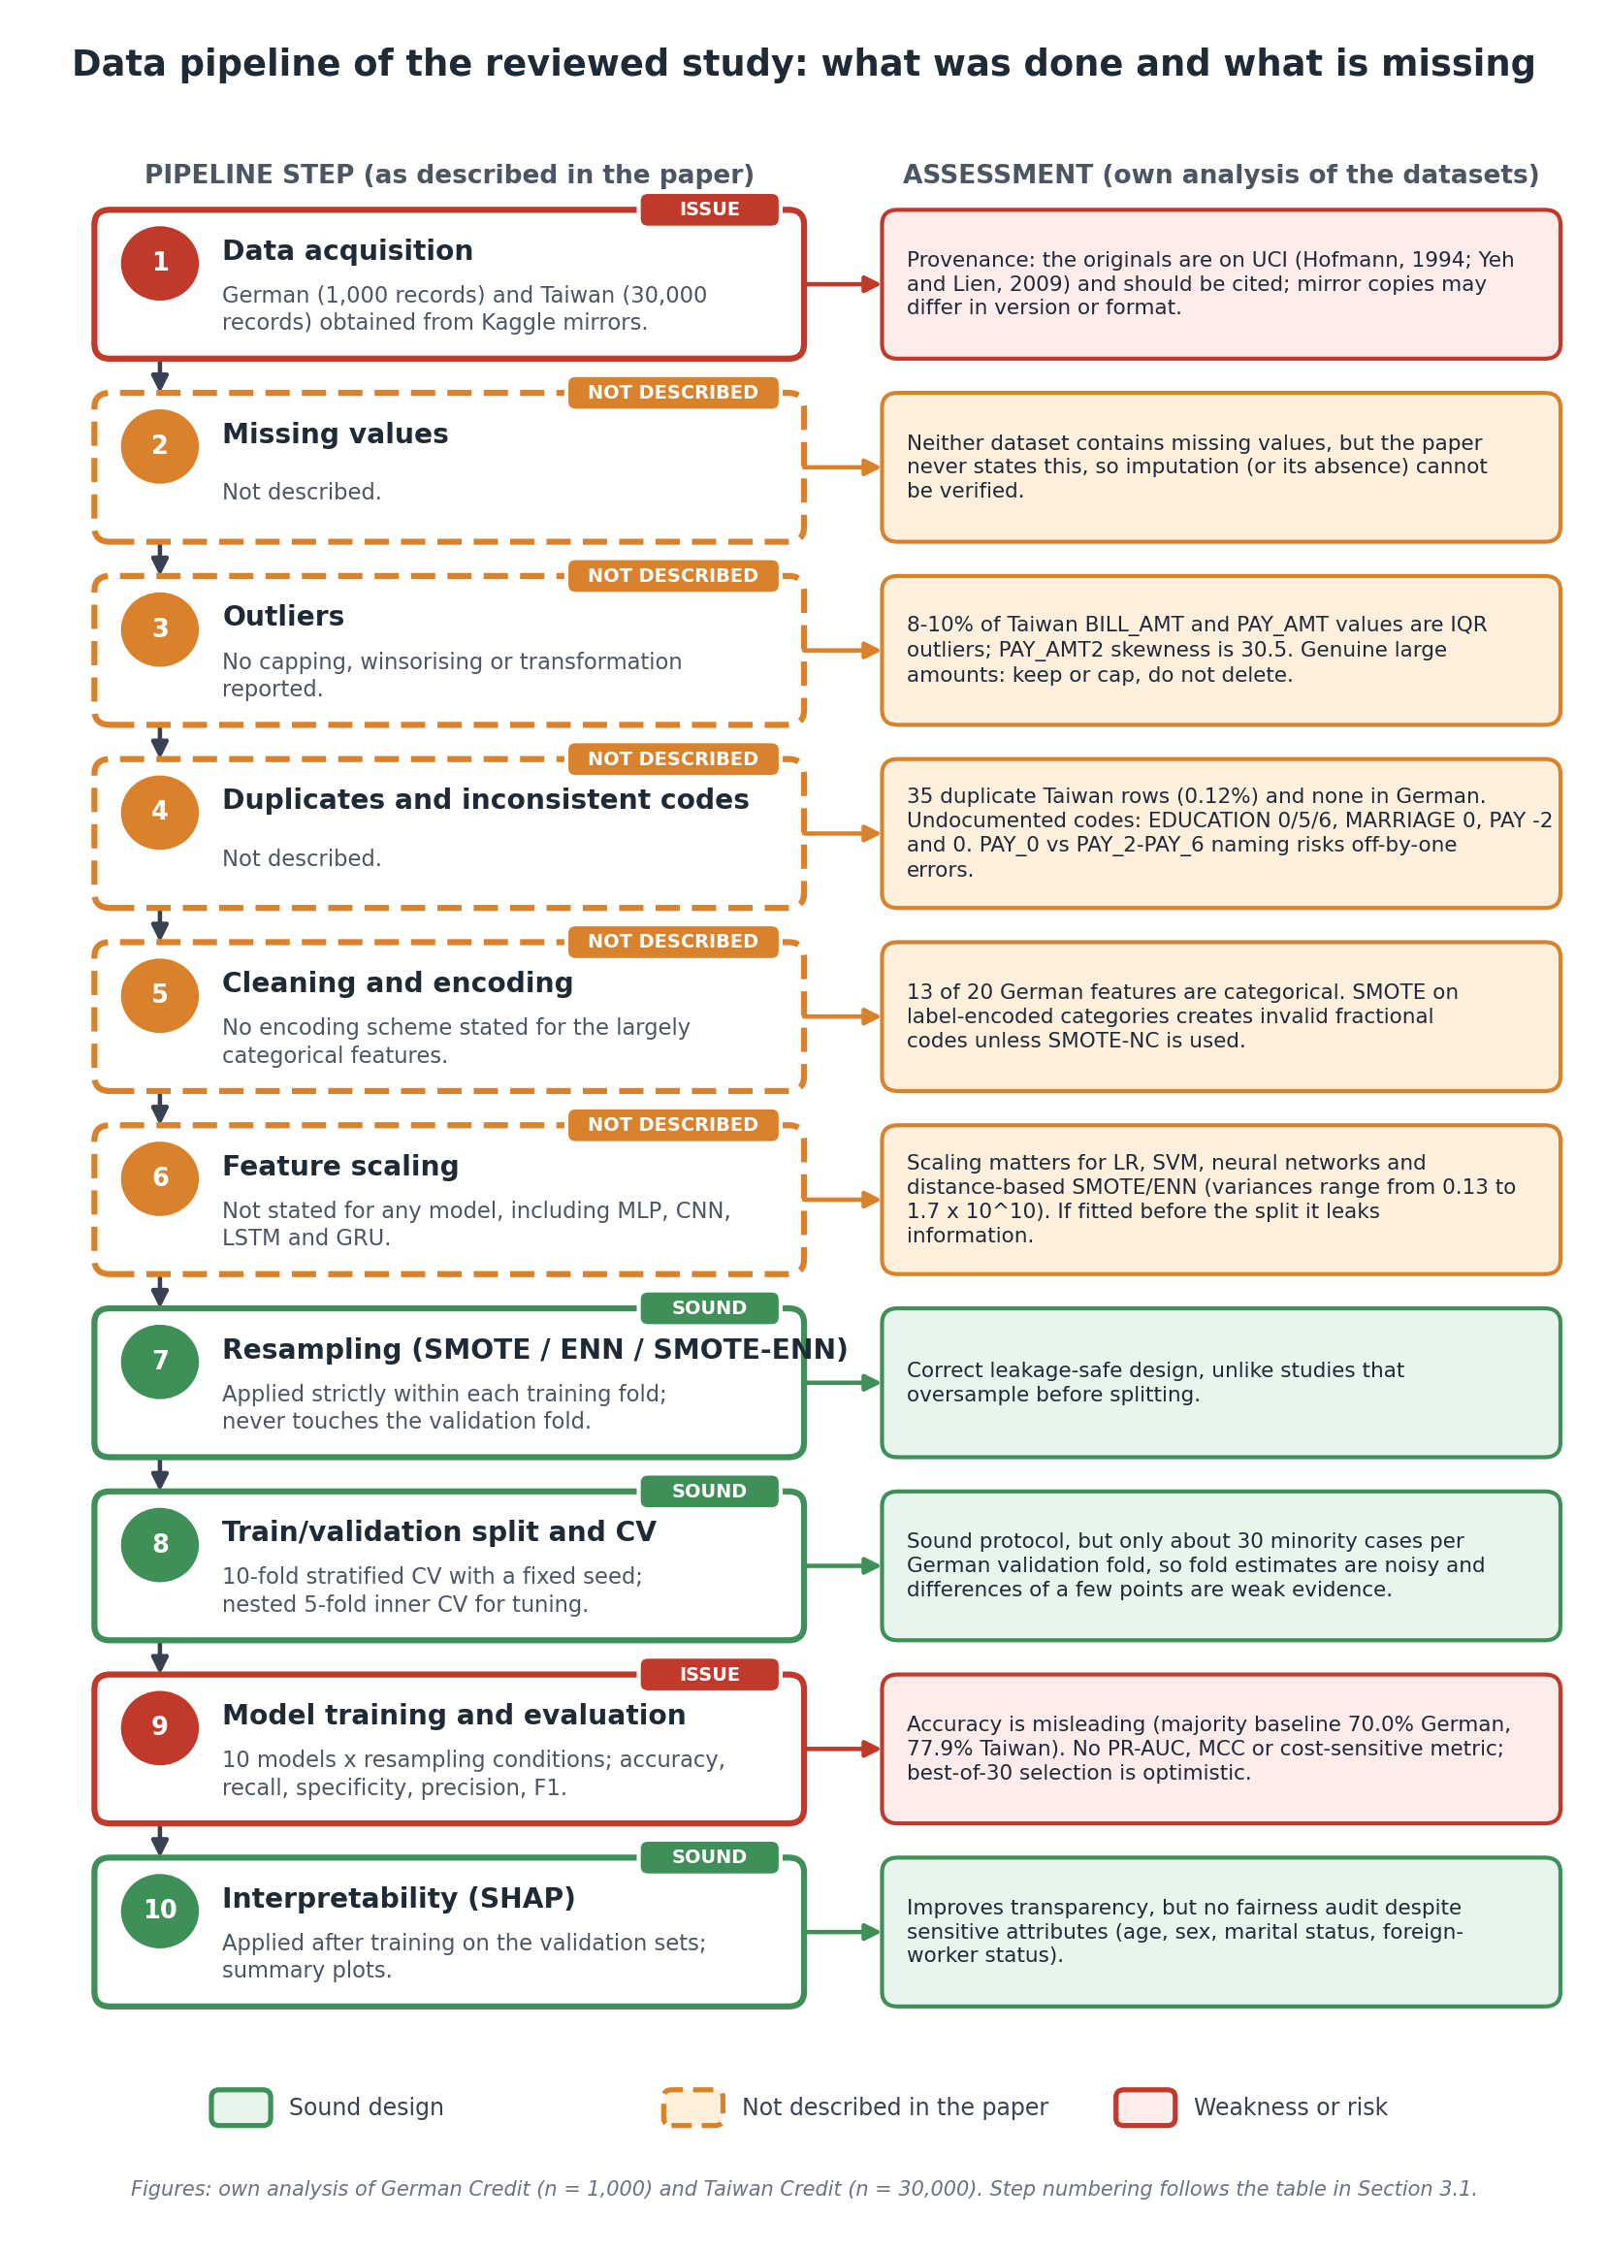
Figure 3.1: Data pipeline of the reviewed study. Green boxes mark sound design choices, orange dashed boxes mark steps the paper does not describe, and red boxes mark weaknesses. Step numbers follow the table above.
Figure 3.1 maps each pipeline step to an assessment. Resampling inside training folds, stratified nested cross-validation and SHAP are sound design choices (steps 7, 8 and 10). Five preparation steps are not described at all: missing values, outliers, duplicates and inconsistent codes, encoding, and scaling (steps 2–6). Two steps carry weaknesses: data sourced from Kaggle mirrors rather than UCI (step 1), and an evaluation that relies on accuracy and F1 with no cost-sensitive or threshold-free metric (step 9).

3.2 Overall Assessment
One key discovery made in this study of data pipelines is that this methodology keeps in mind problems arising from oversampling as well as feature transformation of the original data set. Unlike similar studies in this field which use oversampling at the first stages of data processing, this research successfully avoids any problems associated with oversampling and feature transformation done before the data set is divided into training and testing sets.
Nonetheless, there are two principal flaws in the pipeline that has been provided- absence of specified encoding methods for the categorical majority of features in both datasets, and elimination of feature scaling methods for testing. Despite the fact four out of ten models are based on gradient architecture with known impact scaling into consideration, both issues hinder reproducing results mentioned in the study and should be made clear in the Methodological Critique part of the review. One more point to mention is related to data sets sourcing- both datasets were provided through Kaggle mirrors while their resource of origin, which is more appropriate to mention when citing a research, is UCI Machine Learning Repository.

3.3 Errors and Weaknesses Identified in the Pipeline
- Encoding is not defined, yet SMOTE generates samples by interpolation. On label- or ordinally-encoded categorical features this produces fractional codes that correspond to no real category unless SMOTE-NC is used. The effect is greatest for the German data, where 13 of 20 features are categorical.
- Scaling is not mentioned for the distance-based resamplers. SMOTE and ENN use k-nearest-neighbour distances, so an unscaled CreditAmount (variance about 8 × 10⁶) dominates binary dummy variables and distorts the neighbourhoods. The same gap affects the gradient-based models.
- If scaling or encoding were fitted on the full data before the split, information leaks into the validation folds. The paper does not say which was done.
- Handling of missing values, outliers, duplicates and undocumented codes is not reported, and the highly skewed monetary features are used without transformation.
- The data are cited via Kaggle mirrors rather than the original UCI sources, which weakens provenance.
- The metric and selection problems described in Section 2.6, and the architectural mismatch of the CNN on the German data discussed in Section 2.2.
Done correctly: resampling strictly inside training folds, stratified folds, nested tuning and a fixed seed.

3.4 Pipeline Sub-Workflows and Proposed Enhancements
• Preprocessing: original data → correct codes and repetitions → encode (in-fold) → scale (in-fold).
• Training: training fold → resample → model fitting.
• Tuning: inner 5-fold → candidate hyperparameters → optimal settings → refit on the outer fold.
• Evaluation: outer validation fold → predictions → metrics → mean ± SD across folds.
Improvements: SMOTE-NC or class weights for categorical data; cost-sensitive learning and threshold tuning; log-transformation of skewed amounts; repeated nested CV with significance testing; reporting of PR-AUC and MCC; a fairness audit; probability calibration; and full reproducibility (fixed seeds, versioned code and data, documented environment).

3.5 Summary
The paper compares ten classifiers under three resampling strategies on two credit datasets, using a leakage-aware design (in-fold resampling, stratified 10-fold CV, nested 5-fold tuning and a fixed seed). Its main weaknesses are the unspecified encoding and scaling, the absence of missing-value, outlier and undocumented-code handling, a metric set dominated by accuracy and F1 with no cost-sensitive or threshold-free measure, a small German sample that makes fold estimates noisy, and the weak fit of CNN and LSTM/GRU to the German data. The dataset analysis shows heavily skewed monetary features, a strongly collinear BILL_AMT block, undocumented category codes in Taiwan, and sensitive attributes with no fairness audit. These findings lead into the technical review in Phase 3.

